Lab 16
(Week 12 Lab 1)

The standard deviation of a list of numbers is a measure of how much the numbers deviate from the average. (If the standard deviation is small, the numbers are clustered close to the average. If the standard deviation is large, the numbers are scattered far from the average.) The standard deviation, S, of a list of N numbers x_{i} is defined as

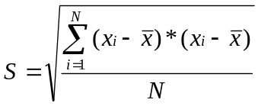

where is the average of the N numbers x₁, x₂, …, x_{n}

Read in 50 numbers of type double from ‘numbers.dat’ and store them into an array. Utilizing functions as necessary, find the average of the numbers in the array, and calculate the standard deviation of the array elements. Display to the screen the list of numbers in the array along with the average and standard deviation of the numbers.

Running with the numbers.dat file found at http://web.umr.edu/~mrghx4/assignments/numbers.dat, your run should look like this:
(If you head under assignments, right-click on the numbers.dat file and choose “save as” and navigate to your S:\ where you have your program, this will save you from extra typing and file manipulation)

ultra15(37)>lab16
50 inputs out of 50 completed...
I found your average to be: 470344
The standard deviation of your numbers is then: 261326
ultra15(38)>

